Final Project: Claire Geiser, Matthew Mills, Pete Albin, Tyre Harrison, Hao Wu, Cassidy Molnar

**Objective and Target Audience**

Cars are everywhere! It seems like cars are everywhere you turn and that means there is pollution and traffic jams everywhere you turn. The main goal of our Red Line app is to give citizens alternatives that they will actually want to use.  If you are tired of being stuck in traffic with excessive pollution being released in your breathing space, we have a seat for you about 5 minutes away from any Red Line bus stop. Our Red Line Application will address problems between commuters and public transportation. The Red Line App will allow users to track the locate of each bus that is in the Red Line. This means that you will always know which bus is the most convenient for your trip.

            Public transportation always plays a big role in the development of cities, examples include New York, Boston, Chicago, and many more highly populated cities. Indianapolis is growing rapidly every day, so it only makes sense for the Redline to flourish. In the growing city, you will need to know how to get around right? Our app will always be right in your pocket to let you know where buses are, and they will be going next. Let us help you keep up in the rapidly growing world.

**Topic Research**

Case Study: Ebus Hybrid Electric Buses and Trolleys by R. Barnitt

Summary:

The Advanced Vehicle Testing Activity (AVTA) was performed by the U.S. Department of Energy. This test was designed to bring research and development closer together. It shows different ways that we can save the environment through air quality and advanced transportation technologies. They also show different fuels, so we aren’t as dependent on foreign oil. There are evaluations done to see how the alternative fuel is participating in other vehicle technology programs such as gathering on site data. Knowing that the bus system being used is safe will help the users of our app be more comfortable in using it.

College Avenue Corridor: The Future towards transit oriented development in Indianapolis by Jennifer Clawson and Brandon Bart

Summary:

Through a studio project where students designed a development proposal this student breaks down the effects a transit-oriented development would have on the intersections of 38thstreet and College Avenue and 49thstreet and College Avenue. They found that this is an old theory that the government is bringing back to meet the new modern needs. The student brings up the transit that Indianapolis is working on and how it could improve the quality of life for residents and create new opportunities for guests. This could advance Indianapolis as a more modern and advanced city. The student then relates the red line back to the College Avenue Corridor. Knowing the similarities through other apps and systems in cities could help us evaluate what we need to do and what needs to be done.

Introduction to Indy by Kristi L. palmer

Summary:

This article is all about the destinations around Indianapolis that could be options to stop at on the bus ride. These tourist attractions include the cultural trail intersection, IUPUI university library, NCAA headquarters, circle center mall, etc. They explain the importance and what each place is. This is helpful for our project to know what places are most important to have on the bus route. Tourists visiting the city will be most of the population using this bus system so knowing where they visit most is helpful.

Frequent network bus system: an analysis of Houston’s bus re-imagining’s impact access by Gavin John Pritchard

Summary:

This report is about the impacts that a redesign of the Houston, Texas bus system will have on the city. It goes over certain topics such as the theory behind the new system, the role of frequent networks, all-day service, gridded coverage, and perceptions of transfers. It also goes over the positive outcomes that could come from a successful new system. Then it talks about how not having this new system effects those whose access has been altered. Knowing how this system is affecting the city of Houston can help us predict what it will do here and who will be using it the most. From that data we know who our target audience is and who we need to plan for using our app.

Does Indianapolis Need Dedicated Bus Lane? By Randal O’Toole

Summary:

This article is talking about all the problems that the red line could cause for the city of Indy. It goes through each topic such as how the people who would be taking the bus is a very small population. Also, how the buses may go a little faster with their own lane, but it will cause more traffic for those still driving cars. Another problem they talk about is the fact that the bus is oversized, expensive, and will do more harm than good. By seeing the effects of a bus system we can calculate who will still use the bus system such as those who care more about getting to work fast instead of saving the environment. This will allow us to plan for who will be using the app making it more user friendly.

**Works Cited**

<https://scholarworks.iupui.edu/bitstream/handle/1805/7412/Intro%20to%20Indy%20CRL%20News%202013.pdf;sequence=1>

<https://www.nrel.gov/docs/fy06osti/38749.pdf>

<http://cardinalscholar.bsu.edu/handle/123456789/198032>

<https://repositories.lib.utexas.edu/handle/2152/34590>

**User Research**

For research on our community we provided a paper survey around the community. Based on the feedback of the community will show the support for the Red Line and our app that works alongside the Red Line Transit. The survey consisted of nine questions provided below:

1.       How old are you?

2.       How long have you lived in the Central Indianapolis area?

3.       What is your preferred mode of transportation?

4.       Would you use a Red Line Route?

5.       How often would you use the Red Line to get around?

6.       What would you use the Red Line for?

7.       Do you think a phone app can help you with routes on the Red Line?

8.       Would you use an app if it was meant to assist you with the local Red Line?

9.       How often would you use a Redline App assist you with bus locations and routes?

The survey was given to two people throughout the city of Indianapolis and here are the statistics that were gathered from the results:

1.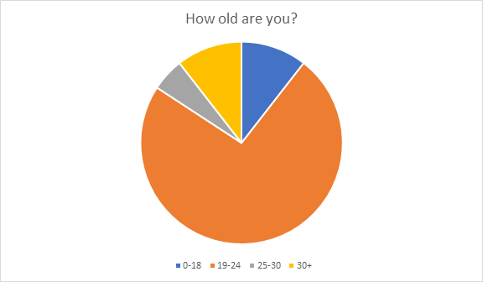

This question in the survey shows not only the median age of who was given the survey, it also shows who was interested in taking the survey. The age group of 19-24 is the majority group meaning that our target audience would mostly consist of college students and young adults.

2.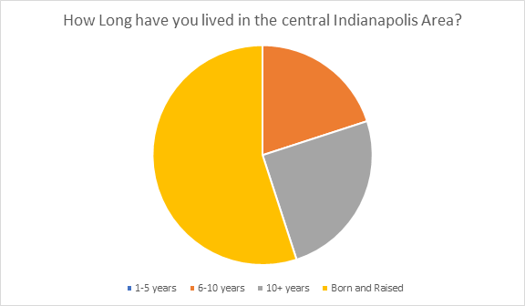

This question in the survey displays the background of the community. Eleven of the twenty surveyors were born and raised in Indianapolis, this shows that our target audience will be made of most Indiana born users.

3.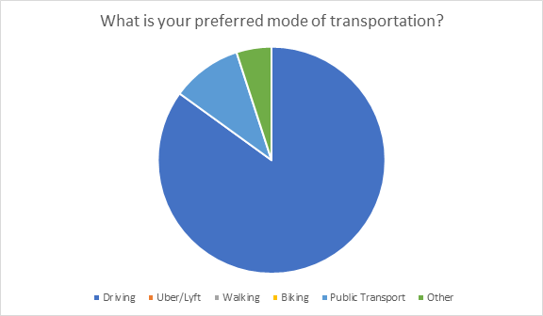

This question in the survey shows the type of transportation that is common within the city of Indianapolis. The majority of surveyors preferred driving their own vehicles. Red Line Routes will be an alternative to the norm.

4.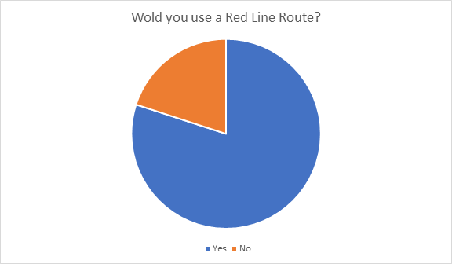

This question in the survey shows the desire to new forms of transportation, specifically the Red Line Routes. A majority of surveyors are willing to give the new bus system a try but there were still others who prefer their current mode of transport.

5.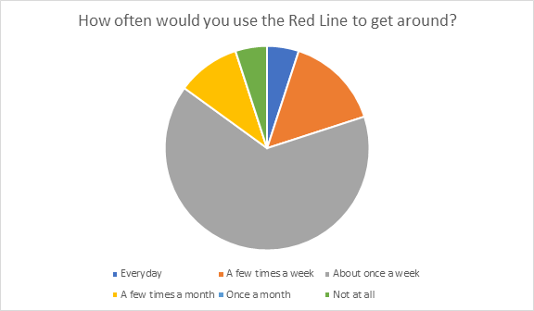

This question in the survey shows how dependent the surveyors would be for the Red Line. A majority of the surveyors chose to use the Red Line once a week, meaning the dependence would not be high.

6.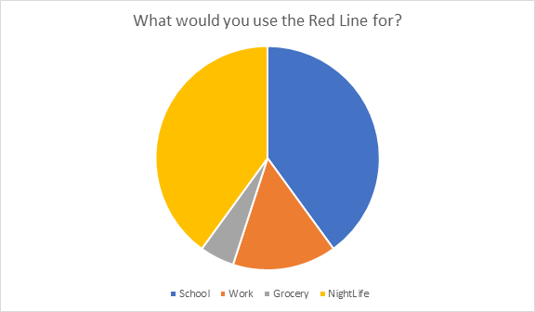

This question in the survey shows what the Red Line would be used for. Nightlife and School share the primary reason with each having 8 of the votes. This helps select the proper audience to promote our app to.

7.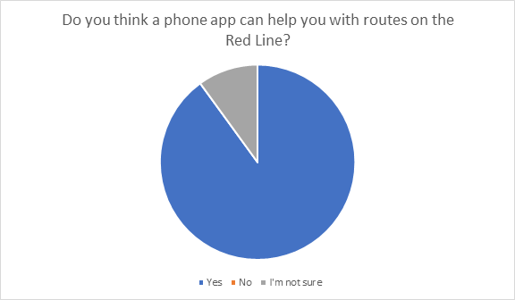

This question in the survey is to gather the surveyor’s knowledge on Routing apps and confidence in them.

8.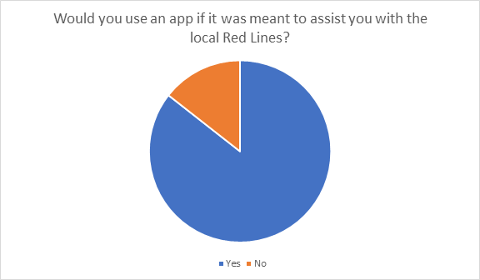

This question in the survey is to see if users would even use an app to help find Red Line Buses. Nineteen out of the twenty surveyors would use an app to get around with the Red Line. The app should be a success with our target audience based on the results.

9.  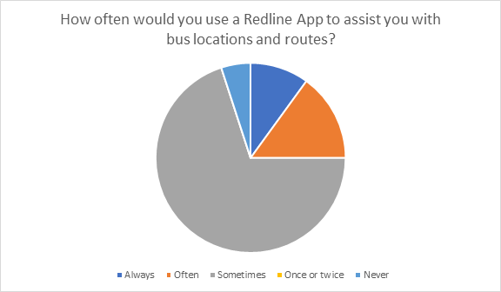

This question in the survey is to see if users would continue to use the app as long as they were riding the Red Line. Surveyors felt that they may become accustomed to the scheduling and would mainly use the accompanying app sometimes.

**Persona**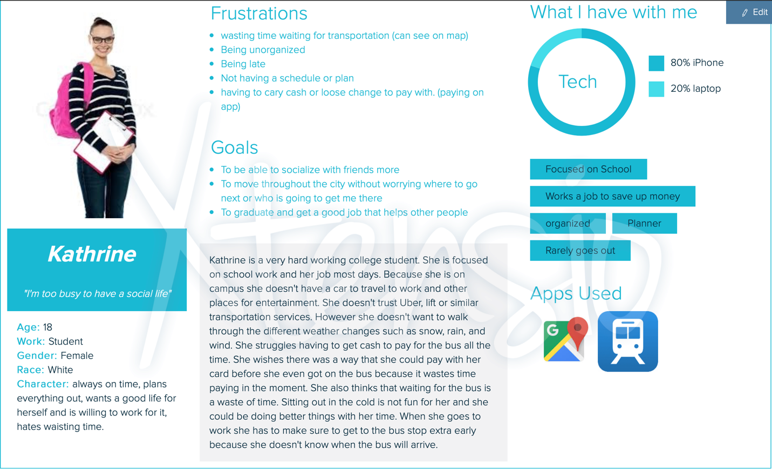

**Design alternatives**

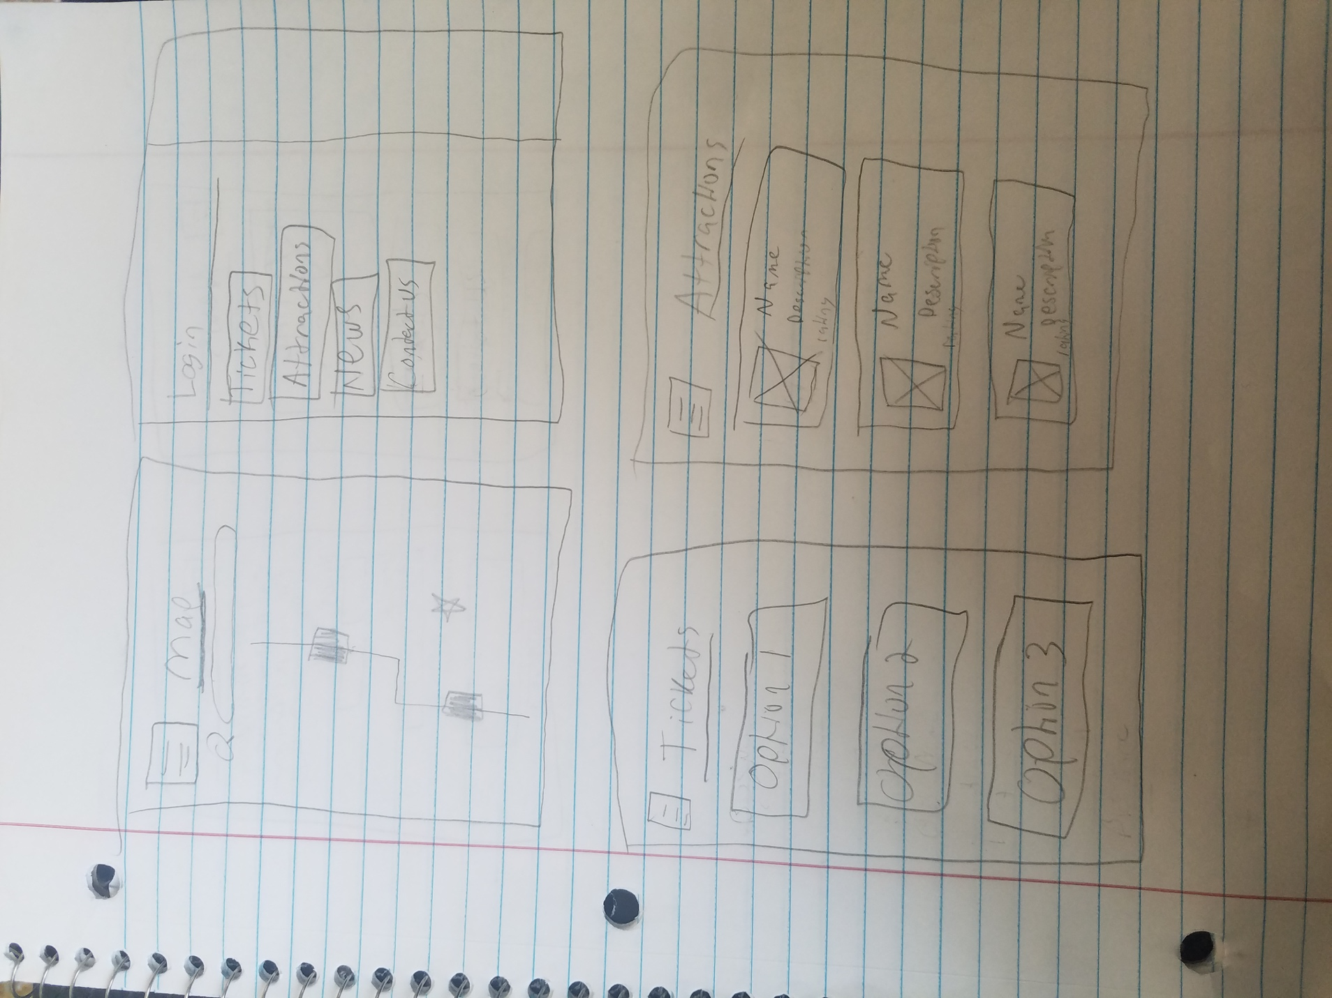

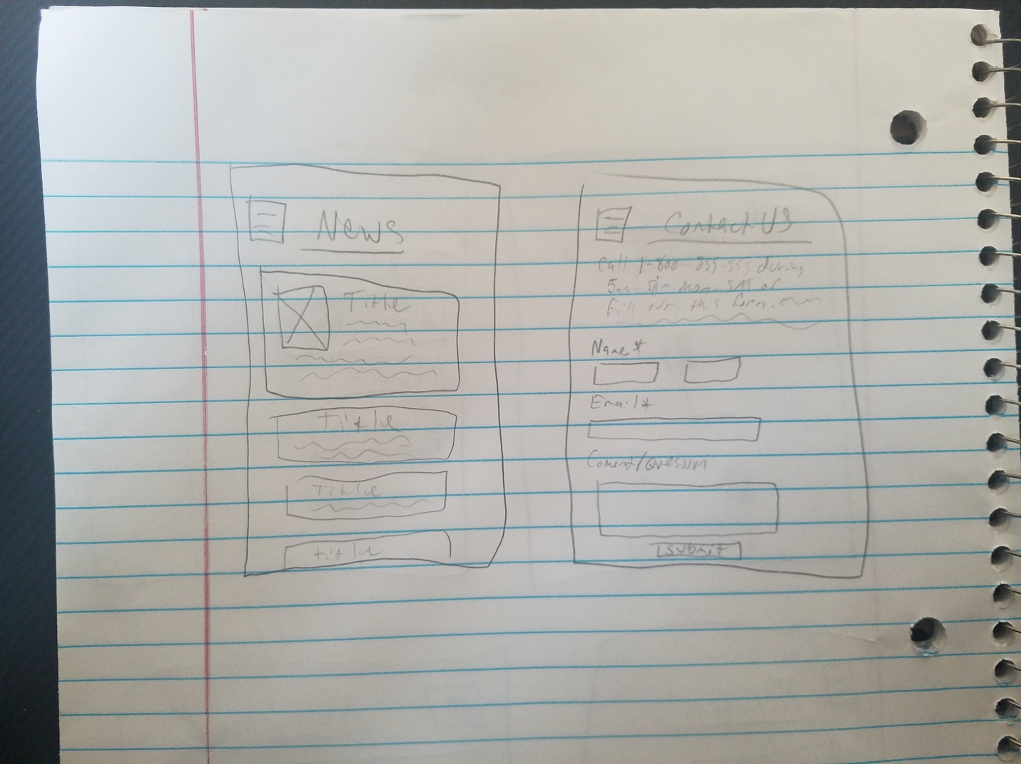

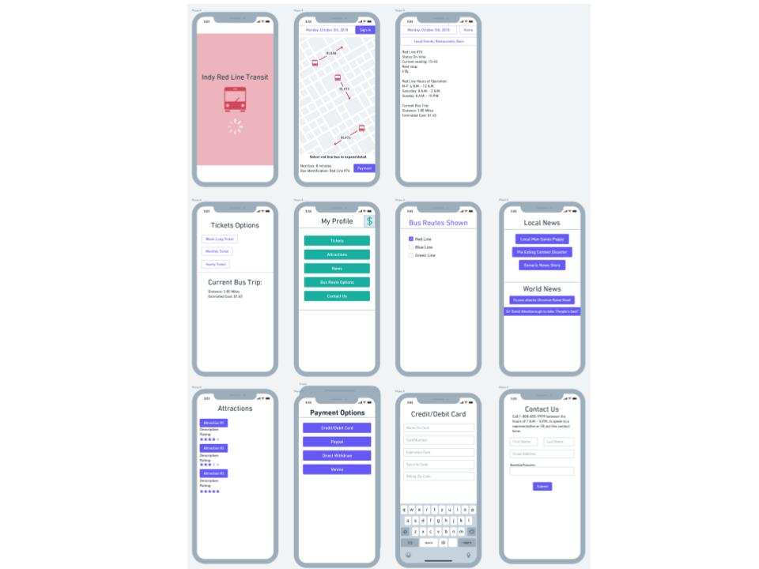

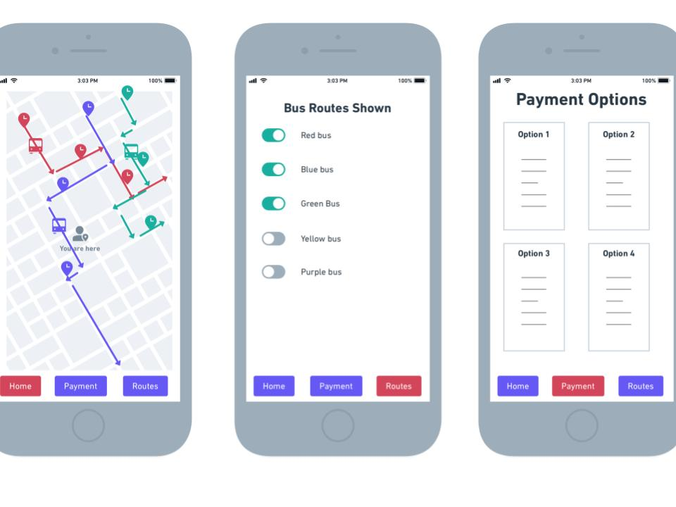

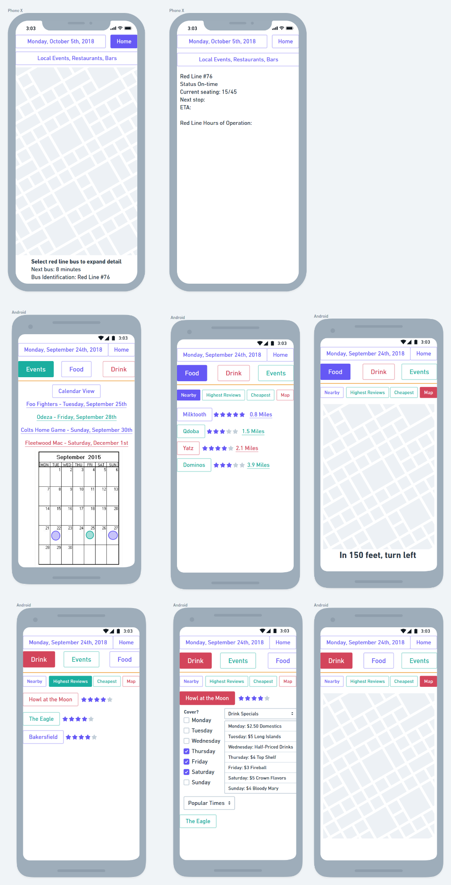

**Low fidelity prototype**

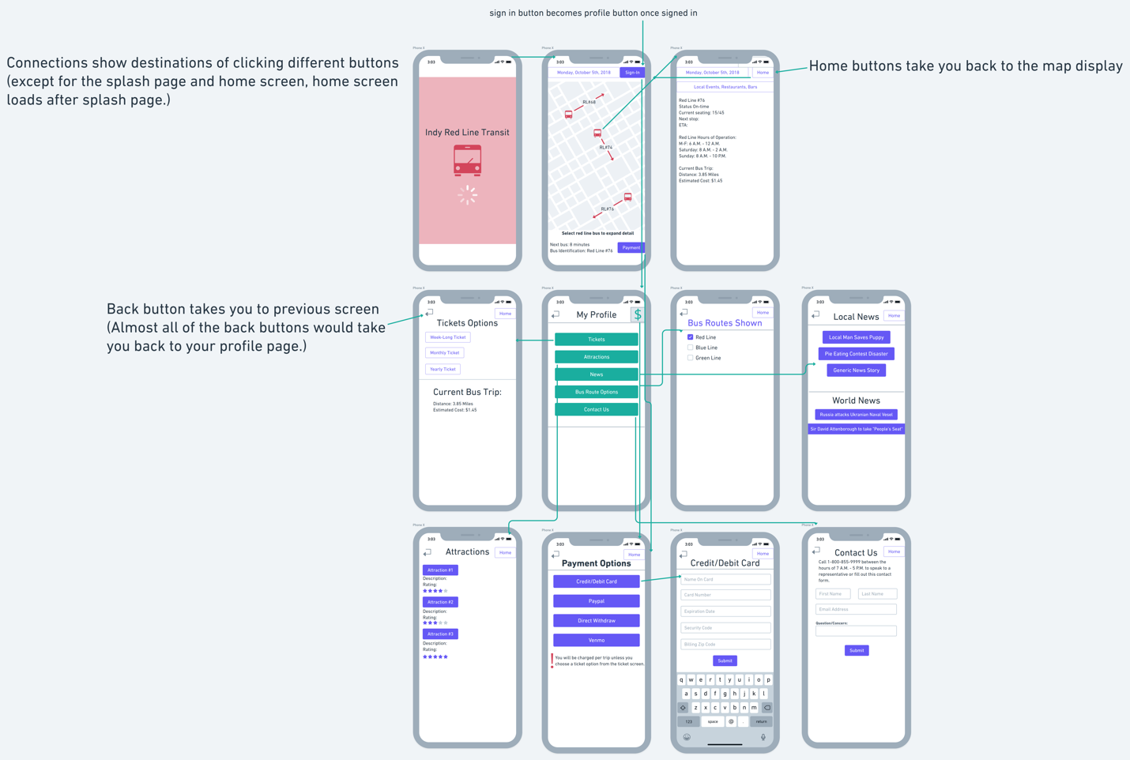

**Usability testing**

**Test 1:**

Introduction

Today we are going to ask you to navigate through a mockup of our Red Line application. We are trying to get a better understanding of how easy it is for users to utilize the app.The entire session may take about 30 minutes. Participation in this test is completely voluntary and all information obtained will remain anonymous.

I will be reading the following questions and instructions from notes to ensure consistency. If you come across any problems during the test be aware that those are exactly the issues we are looking for. I will not be able to provide any help because we are interested in seeing how you solve any problems you encounter. While working through the tasks in this test I would like you to speak out loud any thoughts or reactions that come to mind. If you remain silent for a prolonged amount of time I may ask you to start speaking again. At the end of the test I will have a few follow-up questions and can address any remaining concerns you may have. Do you have any questions so far?

Thank you. Now let’s begin.

Instructions

**Splash screen**

What would you expect to see once this screen is finished loading? (Login options, homepage, etc.)

Probably something along the lines of bus scheduling, ways to pay for bus, bus pass information.

**Bus Route Map**

What are your initial thoughts of this screen?

Seems simple enough, tells you which line is going where, does not give times but provides date, describes next bus time, I would assume clicking on a line will provide bus information.

When using this application, what would you want to do first? (Login)

Scheduling and bus route, how long it will take, cost

What would you do if you wanted to view more information about a specific bus? (Select bus)

Tap and hold one of the icons to view more information about bus such as the hours it’s running. If I were to tap on this screen it would provide cost.

Show me how you would accomplish this.

Clicks and holds bus

On a scale of 1-5, 1 being extremely easy and 5 being extremely difficult, how difficult was this task?

2

Is this what you would expect to see on this page? Why or why not?

Yes actually. It provides all the information I would expect and more.

How would you go back to the map screen? (Home)

I would stopping holding the screen. Wait now I see a home button so I would click that.

Show me how you would accomplish this.

Clicks home screen

On a scale of 1-5, 1 being extremely easy and 5 being extremely difficult, how difficult was this task?

1

**Sign in**

What would you do to login? (Sign-in button)

Tap the sign in button at the top right corner of screen.

Show me how you would login.

Clicks login button

On a scale of 1-5, 1 being extremely easy and 5 being extremely difficult, how difficult was this task?

1

Is this what you would expect to see on this page? Why or why not?

I expected to see this page as soon as I opened the app.

**Add money to account**

How would you add money to your account to pay for your bus trip? (Money symbol)

I assume the giant money button up in the corner

Show me how would accomplish this.

Clicks money symbol

On a scale of 1-5, 1 being extremely easy and 5 being extremely difficult, how difficult was this task?

1 but having more information besides a big money symbol would be helpful. Could use the space for settings.

Is this what you would expect to see on this page? Why or why not?

For the most part yes, It provides a variety of payment options.

How would you return to the profile screen?

Back button. But the home button makes it confusing.

On a scale of 1-5, 1 being extremely easy and 5 being extremely difficult, how difficult was this task?

2

**Tickets**

What would you do if you wanted to purchase a ticket? (Tickets)

ticket button

Show me how you would purchase a ticket.

Clicks ticket button

On a scale of 1-5, 1 being extremely easy and 5 being extremely difficult, how difficult was this task?

1

Is this what you would expect to see on this page? Why or why not?

No not really. If I had tickets I assume it would show me all the current running lines. I don’t know how buses work but I would assume there should be options for one day not just long term options.

**Route options**

What would you do if you wanted to view more routes that are available? (Bus route options)

Bus route options

Show me how you would accomplish this.

Clicks bus route options

On a scale of 1-5, 1 being extremely easy and 5 being extremely difficult, how difficult was this task?

1

Is this what you would expect to see on this page? Why or why not?

No. Why would you have other line options here? Basically what I’m expecting to see here is a menu of route options instead of the route options on the map. If I select this will it only show red or blue or green line now?

**Attractions**

What would you do if you wanted to view popular areas near your desired bus stop? (attractions)

attractions

Show me how you would accomplish this.

Selects attractions

On a scale of 1-5, 1 being extremely easy and 5 being extremely difficult, how difficult was this task?

1

Is this what you would expect to see on this page? Why or why not?

For the most part.

**News**

What would you do if you wanted to read news articles?

News button

Show me how you would accomplish this.

Selects new button

On a scale of 1-5, 1 being extremely easy and 5 being extremely difficult, how difficult was this task?

1

Is this what you would expect to see on this page? Why or why not?

No. With this app being about the red line I expect news about bus delays, traffic jams, bus news, etc.

**Contact us**

What would you do if you had questions or concerns regarding this app? (Contact us)

Contact us button

Show me how you would accomplish this.

Selects contact us button

On a scale of 1-5, 1 being extremely easy and 5 being extremely difficult, how difficult was this task?

1

Is this what you would expect to see on this page? Why or why not?

Yes, but if you already have a profile they should have all your information already. There should just be contact info and a place to type in and questions and concerns.

Follow-Up Questions

Now I have a few follow-up questions for you.

Overall, how would you describe your experience using the application?

It’s fine. There's a couple of glaring user interface issues but that's really it. The only thing I can think of is if you want it to be about all the lines then do so. Don’t only make it about the red line.

On a scale of 1-5, 1 being extremely easy and 5 being extremely difficult, how difficult was it to use this app?

2

How confident are you in your ability to use it again?

Fairly confident

What did you like the most about this app?

It’s easy enough to use.

What did you like the least?

Bus route options button. It’s an app about the red line so it should only provide information about the red line.

Do you have any suggestions?

My profile screen pops up after using fingerprint identification to log in.

Cut down on useless buttons like money button. There could be a settings button. The settings button could have payment information and contact us options.

Thank you for taking the time to help us understand what users think of our application and its ease of use.  If you decide you would like to terminate your results we can do so within the first 30 days after you’ve completed this test. Here is a receipt number that you can take with you to confirm your testing information if you decide to terminate your results. Our phone number can be found on the back if you need to contact us to do so or if you have any additional questions later. This concludes our test.

Do you have any final questions or comments?

**Test 2:**

Introduction

Today we are going to ask you to navigate through a mockup of our Red Line application. We are trying to get a better understanding of how easy it is for users to utilize the app.The entire session may take up to 1 hour. Participation in this test is completely voluntary and all information obtained will remain anonymous.

I will be reading the following questions and instructions from notes to ensure consistency. If you come across any problems during the test be aware that those are exactly the issues we are looking for. I will not be able to provide any help because we are interested in seeing how you solve any problems you encounter. While working through the tasks in this test I would like you to speak out loud any thoughts or reactions that come to mind. If you remain silent for a prolonged amount of time I may ask you to start speaking again. At the end of the test I will have a few follow-up questions and can address any remaining concerns you may have. Do you have any questions so far?

Thank you. Now let’s begin.

Instructions

**Splash screen**

What would you expect to see once this screen is finished loading? (Login options, homepage, etc.)

Something similar to google maps an aerial view of the location, maybe the bus route and bus stops local to me, and maybe buy tickets.

**Bus Route Map**

What are your initial thoughts of this screen?

It looks like the GPS location of the buses around

When using this application, what would you want to do first? (Login)

Sign in at the top right

What would you do if you wanted to view more information about a specific bus? (Select bus)

Click bus

Show me how you would accomplish this.

Selects bus

On a scale of 1-5, 1 being extremely easy and 5 being extremely difficult, how difficult was this task?

2

Is this what you would expect to see on this page? Why or why not?

Yes. The only thing that appears to be missing is a button that would provide instructions on how to get to the specific location “take me there” and/or provide address.

How would you go back to the map screen? (Home)

Click home button

Show me how you would accomplish this.

Select home button

On a scale of 1-5, 1 being extremely easy and 5 being extremely difficult, how difficult was this task?

3, back button at the top right does not follow common user experience design. It should be pn the left.

**Sign in**

What would you do to login? (Sign-in button)

Press sign in button

Show me how you would login.

Selects sign in button

On a scale of 1-5, 1 being extremely easy and 5 being extremely difficult, how difficult was this task?

3, signing in should be the first thing I do

Is this what you would expect to see on this page? Why or why not?

Is this whats suppose to show up after logging in? This is confusing. I would expect to see a login screen before automatically going to my profile.

**Add money to account**

How would you add money to your account to pay for your bus trip? (Money symbol)

Top right button. This could just be a button in the middle center I don’t understand why it would be in the top right. Also why is the back button on the top left here but it was in the top right on other screens?

Show me how would accomplish this.

Select money symbol

On a scale of 1-5, 1 being extremely easy and 5 being extremely difficult, how difficult was this task?

4, the purpose of the money symbol is unclear

Is this what you would expect to see on this page? Why or why not?

Why is there a back button and a home button? Don’t they do the same thing?

Other than that yes this is what I would expect to see on this screen.

How would you return to the previous screen?

Top left button

On a scale of 1-5, 1 being extremely easy and 5 being extremely difficult, how difficult was this task?

3

**Tickets**

What would you do if you wanted to purchase a ticket? (Tickets)

I don’t know. I see a payment option. Do I need to add cash to the app beforehand? If I do there’s no disclaimer. I don’t like the idea of having a balance on this app. I would probably see if I could directly pay for by using the ticket screen.

Show me how you would purchase a ticket.

Selects tickets

On a scale of 1-5, 1 being extremely easy and 5 being extremely difficult, how difficult was this task?

3

Is this what you would expect to see on this page? Why or why not?

No, I’m looking for a one way ticket. Is this suppose to be like a bus pass?

**Route options**

What would you do if you wanted to view more routes that are available? (Bus route options)

Bus route options button

Show me how you would accomplish this.

Selects bus route options

On a scale of 1-5, 1 being extremely easy and 5 being extremely difficult, how difficult was this task?

1

Is this what you would expect to see on this page? Why or why not?

No, I would expect this to be like an alternate route type of thing. This just shows me other buses.

**Attractions**

What would you do if you wanted to view popular areas near your desired bus stop? (attractions)

I would go to google but since there's an attractions option I guess I would click that. Why is that there?

Show me how you would accomplish this.

Selects attractions button.

On a scale of 1-5, 1 being extremely easy and 5 being extremely difficult, how difficult was this task?

2

Is this what you would expect to see on this page? Why or why not?

Are these attractions around the bus stops or attractions near me?

**News**

What would you do if you wanted to read news articles?

I wouldn’t use this app. But I guess I would select the news button. Why is this on here?

Show me how you would accomplish this.

Selects news button

On a scale of 1-5, 1 being extremely easy and 5 being extremely difficult, how difficult was this task?

2

Is this what you would expect to see on this page? Why or why not?

No. Why is world news on here? This doesn’t make any sense.

**Contact us**

What would you do if you had questions or concerns regarding this app? (Contact us)

Contact us

Show me how you would accomplish this.

Selects contact us

On a scale of 1-5, 1 being extremely easy and 5 being extremely difficult, how difficult was this task?

1

Is this what you would expect to see on this page? Why or why not?

Sorta. There should be more here. There should be a response email option. There should also be a field to select the type of issue.

Follow-Up Questions

Now I have a few follow-up questions for you.

Overall, how would you describe your experience using the application?

Poor. There is a lack of consistency and some things just don’t make sense.

On a scale of 1-5, 1 being extremely easy and 5 being extremely difficult, how difficult was it to use this app?

3

How confident are you in your ability to use it again?

Very confident

What did you like the most about this app?

I like that I could pay with paypal. It’s easy to use.

What did you like the least?

Amount of useless buttons like world news

Do you have any suggestions?

Eliminate useless options and fix inconsistencies.

Thank you for taking the time to help us understand what users think of our application and its ease of use.  If you decide you would like to terminate your results we can do so within the first 30 days after you’ve completed this test. Here is a receipt number that you can take with you to confirm your testing information if you decide to terminate your results. Our phone number can be found on the back if you need to contact us to do so or if you have any additional questions later. This concludes our test.

Do you have any final questions or comments?

Instructions

**Splash screen**

What would you expect to see once this screen is finished loading? (Login options, homepage, etc.)

Possibly a map, list of buses available, maybe a login screen.

**Bus Route Map**

What are your initial thoughts of this screen?

It looks to be about what I expected, buses on a map.

When using this application, what would you want to do first? (Login)

Probably sign in

What would you do if you wanted to view more information about a specific bus? (Select bus)

Click on one of the buses

Show me how you would accomplish this.

Selects one of the buses

On a scale of 1-5, 1 being extremely easy and 5 being extremely difficult, how difficult was this task?

1

Is this what you would expect to see on this page? Why or why not?

Basically. Having the arrival time on this screen would also be helpful.

How would you go back to the map screen? (Home)

The home button in the upper right corner

Show me how you would accomplish this.

Selects home button

On a scale of 1-5, 1 being extremely easy and 5 being extremely difficult, how difficult was this task?

1

**Sign in**

What would you do to login? (Sign-in button)

Click the login button

Show me how you would login.

Selects login button

On a scale of 1-5, 1 being extremely easy and 5 being extremely difficult, how difficult was this task?

1

Is this what you would expect to see on this page? Why or why not?

No. I expected to see a login screen. It automatically took me to a profile screen.

**Add money to account**

How would you add money to your account to pay for your bus trip? (Money symbol)

Probably the money symbol in the top right corner. Although I’m not quite sure what that symbol is.

Show me how would accomplish this.

Selects money symbol

On a scale of 1-5, 1 being extremely easy and 5 being extremely difficult, how difficult was this task?

1

Is this what you would expect to see on this page? Why or why not?

Yes, it has several payment options.

How would you return to the previous screen?

There’s a back button and a home button. I would probably select the back button but the home button does make it a bit more confusing.

On a scale of 1-5, 1 being extremely easy and 5 being extremely difficult, how difficult was this task?

2

**Tickets**

What would you do if you wanted to purchase a ticket? (Tickets)

Click the tickets option

Show me how you would purchase a ticket.

Selects ticket option

On a scale of 1-5, 1 being extremely easy and 5 being extremely difficult, how difficult was this task?

1

Is this what you would expect to see on this page? Why or why not?

Almost. Is there a way to purchase a one time ticket?

**Route options**

What would you do if you wanted to view more routes that are available? (Bus route options)

Click bus route options

Show me how you would accomplish this.

Selects bus route options

On a scale of 1-5, 1 being extremely easy and 5 being extremely difficult, how difficult was this task?

1

Is this what you would expect to see on this page? Why or why not?

Not at all. Why are there green and blue lines available? Isn’t this a red line app?

**Attractions**

What would you do if you wanted to view popular areas near your desired bus stop? (attractions)

Go to attractions

Show me how you would accomplish this.

Selects attractions

On a scale of 1-5, 1 being extremely easy and 5 being extremely difficult, how difficult was this task?

1

Is this what you would expect to see on this page? Why or why not?

Yes. It would be helpful to know where these attractions are and maybe be able to look at pictures.

**News**

What would you do if you wanted to read news articles?

Click news button

Show me how you would accomplish this.

Selects news button

On a scale of 1-5, 1 being extremely easy and 5 being extremely difficult, how difficult was this task?

1

Is this what you would expect to see on this page? Why or why not?

No. I’m not sure why I would be reading news in a bus app.

**Contact us**

What would you do if you had questions or concerns regarding this app? (Contact us)

Click contact us

Show me how you would accomplish this.

Selects contact us

On a scale of 1-5, 1 being extremely easy and 5 being extremely difficult, how difficult was this task?

1

Is this what you would expect to see on this page? Why or why not?

Yes. It seems to be a basic contact form.

Follow-Up Questions

Now I have a few follow-up questions for you.

Overall, how would you describe your experience using the application?

Neutral. There are some minor issues but the app is usable.

On a scale of 1-5, 1 being extremely easy and 5 being extremely difficult, how difficult was it to use this app?

2

How confident are you in your ability to use it again?

Pretty confident

What did you like the most about this app?

For the most part it was pretty simple

What did you like the least?

Ticket options

Do you have any suggestions?

Get rid of new it serves no purpose.

Thank you for taking the time to help us understand what users think of our application and its ease of use.  If you decide you would like to terminate your results we can do so within the first 30 days after you’ve completed this test. Here is a receipt number that you can take with you to confirm your testing information if you decide to terminate your results. Our phone number can be found on the back if you need to contact us to do so or if you have any additional questions later. This concludes our test.

Do you have any final questions or comments?

Recommendations

* Sign in screen
  + There is currently no login screen. Consider making one instead of immediately jumping to the user profile.
  + Having the sign in screen as the first screen to appear when opening the app would be less confusing for users.
* Bus Route section
  + Users were confused why blue and green lines were included in a red line app. Consider changing this screen to a menu of available buses.
* News section
  + User’s didn’t understand the relevance on having world news in a bus app. Consider only including relevant bus information such as delays, traffic problems, construction, ect.
* Contact Us section
  + Consider including an option for the type of issue a user has.
* Ticket/Payment
  + Users were confused with the floating balance portion of the app, especially the money button. Consider eliminating the charge per distance and have a one way ticket option instead or eliminate the money button and include it as an option on the menu on the My Profile section.
* Home button
  + Having a home button and back button every screen confused users. Users weren’t sure what the home screen was. Consider eliminating the home button or only including it on the My Profile section.

**Metrics**

1. No more than 10 seconds from app launch to payment screen for vast majority of users  (>85%) after usability testing.
2. GPS updates to bus maps should be equal to or less than every 10 seconds
3. Responsiveness times less than or equal to 0.1 sec
4. No more than 5 seconds for home screen to load from splash page.
5. Fewer than 5 errors for a majority (>50%) of usability test users.
6. No more than 2 errors when navigating to payment options for a majority (>50%) of users during usability testing.

**High Fidelity Prototype**

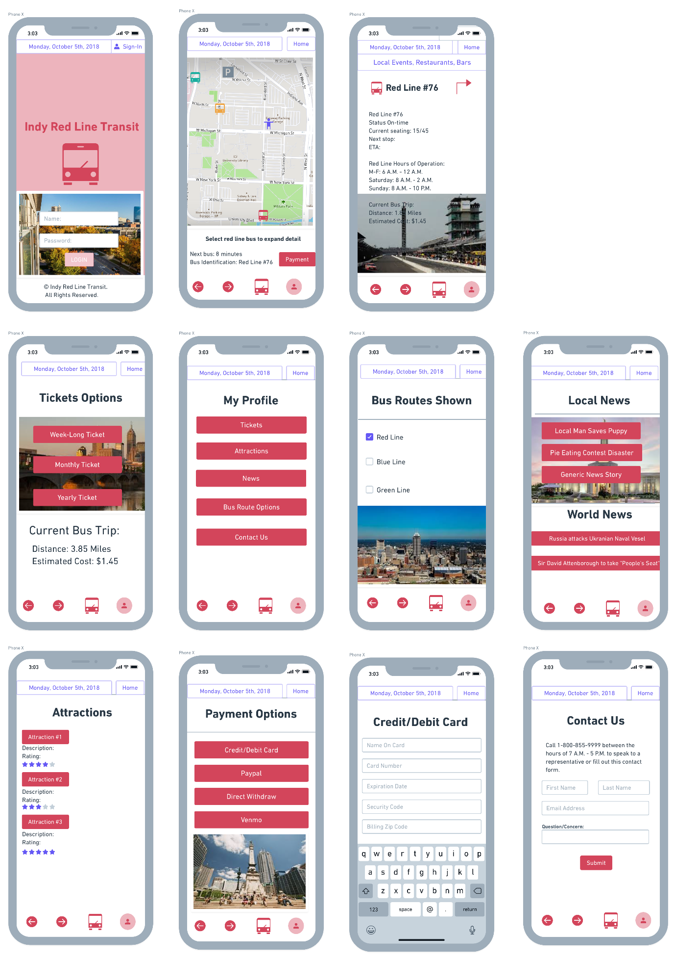

**Project Presentation**



